Reference:

Mexican Culture: Customs & Traditions
Kim Ann Zimmermann, LiveScience Contributor | August 02, 2013 02:25pm

The culture of Mexico has undergone a tremendous transformation over the past few decades and it varies widely throughout the country. Nearly half of the population (112.3 million) lives in cities, but smaller rural communities still play a strong role in defining the country’s collective vibrant community.

Languages of Mexico
While the overwhelming majority of Mexicans today speak Spanish — making it the largest Spanish-speaking population in the world — there is no single official national language of Mexico. The colonizers of Mexico forced the Spanish language on the natives, but in the 1990s the government recognized 62 indigenous Amerindian languages, including Aztec, or Nahuatl, and the Mayan family of languages, as national languages. About 6 percent of the population is non-Spanish speaking, and some indigenous Mexican words have even become common in other languages, including English. For example, chocolate, coyote, tomato and avocado all originated in Nahuatl.

Religions of Mexico
Close to 90 percent of Mexicans identify themselves as Catholic, although many have incorporated pre-Hispanic Mayan elements as part of their faith. About 6 percent identify as Protestant. Christian denominations represented include Presbyterians, Jehovah's Witnesses, Seventh-Day Adventists, Mormons, Lutherans, Methodists, Baptists and Anglicans. There are also small communities of Muslims, Jews and Buddhists.

Mexico City is one of the most populous cities in the world, with 8.8 million people.
The culture of Mexico has undergone a tremendous transformation over the past few decades and it varies widely throughout the country. Nearly half of the population (112.3 million) lives in cities, but smaller rural communities still play a strong role in defining the country’s collective vibrant community.

Languages of Mexico
While the overwhelming majority of Mexicans today speak Spanish — making it the largest Spanish-speaking population in the world — there is no single official national language of Mexico. The colonizers of Mexico forced the Spanish language on the natives, but in the 1990s the government recognized 62 indigenous Amerindian languages, including Aztec, or Nahuatl, and the Mayan family of languages, as national languages. About 6 percent of the population is non-Spanish speaking, and some indigenous Mexican words have even become common in other languages, including English. For example, chocolate, coyote, tomato and avocado all originated in Nahuatl.

Religions of Mexico
Close to 90 percent of Mexicans identify themselves as Catholic, although many have incorporated pre-Hispanic Mayan elements as part of their faith. About 6 percent identify as Protestant. Christian denominations represented include Presbyterians, Jehovah's Witnesses, Seventh-Day Adventists, Mormons, Lutherans, Methodists, Baptists and Anglicans. There are also small communities of Muslims, Jews and Buddhists.

Values of the Mexican people
Mexicans put a high value on hierarchy and structure in business and family matters. Especially outside of cities, families are typically large and Mexicans are very conscious of their responsibilities to immediate family members and extended family such as cousins and even close friends.
Hosting parties at their homes playsa large part of Mexican life and making visitors feel comfortable is a large part of the values and customs of the country.
Most Mexican families are highly traditional, with the father as the authority figure. While more women are working outside of the home in the past several decades, there are still a large number of women who work exclusively in the home. The country remains a male-centric society, and machismo, a word derived from Mexican and Portuguese meaning male supremacy, is prevalent. Mexicans revere people in authority, including educators and medical professionals.

Mexican clothing
In the cities, fashion in Mexico is influenced by international trends, so the typical urban Mexican dresses similar to people in Europe and the United States.
In more rural areas, a typical woman’s wardrobe includes skirts, sleeveless tunics called huipils, capes known as quechquémitls and shawls called rebozos.

One distinguishing article of traditional men’s clothing is a large blanket cape called a sarape. Boots are also a wardrobe staple. Some traditional clothing, now typically worn for celebrations and special occasions, include sombreros and the charro suits worn by Mariachi bands that are popular costumes during Carnival.

Mexican food
Mexican culinary norms vary widely based on income level and social class. The diet of working class Mexicans includes staples such as corn or wheat tortillas, along with beans, rice, tomatoes, chili peppers and chorizo, a type of pork sausage. Empanadas, which are handheld pasty pockets that can contain savory or sweet fillings, are popular.
The diets of middle- and upper-income Mexicans are more closely aligned with diets of Americans and Europeans and include a wide variety of food items prepared in wide range of culinary styles.

Mexico is known for its tequila, which is made from agave cactus that is well suited to the climate of central Mexico. Soda is a very popular drink in Mexico, as the country has a well-developed beverage industry.
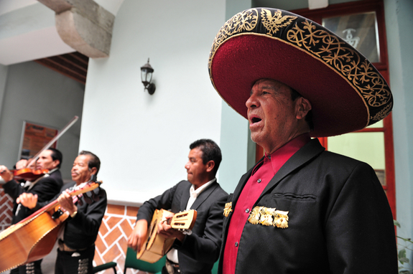
A mariachi band plays music in Puebla. Marichi music is a tradition that goes back to the 19th century.
Credit: ChameleonsEye / Shutterstock.com
View full size image

Mexican art and literature
Clay pottery, embroidered cotton garments, wool shawls and outer garments with angular designs and colorful baskets and rugs are some of the common items associated with Mexican folk art.

The country is closely associated with the Mariachi style of folk music. Originated in the southern part of the state of Jalisco sometime in the 19th century, it involves a group of musicians playing violins, guitars, basses, vihuelas (a five-string guitar) and trumpets wearing silver-studded charro suits and elaborate hats. "La Cucaracha" is a well-known Mariachi staple.

Holidays and celebrations
The Feast of Our Lady of Guadalupe, which is celebrated on Dec. 12, is a major Mexican holiday celebrating of the appearance of the Virgin Mary to an Indian man in the first years of Spanish rule. She is the patron saint of the country.
The Day of the Dead, which is actually celebrated over two days (Nov. 1 and 2) combines Catholic and indigenous rituals to honor the deceased and is a national holiday.
Carnival is also celebrated in many communities throughout Mexico to mark the period before Lent.

Independence Day, marking the country’s separation from Spain in 1810, is celebrated on Sept. 16. Cinco de Mayo, which marks Mexican military victory over the French in 1862, is more widely celebrated in the U.S. than it is in Mexico.

Related:
- Chichen Itza: Mayan Temples in the Yucatan
- Palenque: Mayan City of Temples
- Tenochtitlán: History of Aztec Capital
- Teotihuacan: Ancient City of Pyramids
- Tikal: Capital of Mayan Civilization

