Books we have multiple copies of (4 - 6 copies) to checkout.

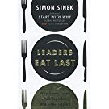

Leaders Eat Last: Why Some Teams Pull Together and Others Don't
by Simon Sinek (Paperback)

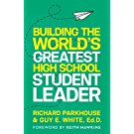

Building the World's Greatest High School Student Leader: Creating a Culture of Significance Where Everyone Matters
by Richard Parkhouse, Guy E White (Paperback)

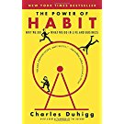

The Power of Habit: Why We Do What We Do in Life and Business
by Charles Duhigg (Paperback)

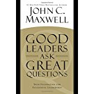

Good Leaders Ask Great Questions: Your Foundation for Successful Leadership
by John C. Maxwell (Hardcover)

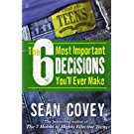

The 6 Most Important Decisions You'll Ever Make: A Guide for Teens
by Sean Covey (Paperback)

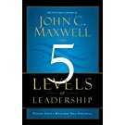

The 5 Levels of Leadership: Proven Steps to Maximize Your Potential
by John C. Maxwell (Paperback)

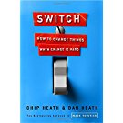

Switch: How to Change Things When Change Is Hard
by Chip Heath, Dan Heath (Hardcover)

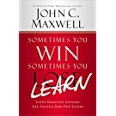

Sometimes You Win--Sometimes You Learn: Life's Greatest Lessons Are Gained from Our Losses
by John C. Maxwell, John Wooden (Paperback)

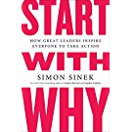

Start with Why: How Great Leaders Inspire Everyone to Take Action
by Simon Sinek (Paperback)

A single copy available in the library of these books:

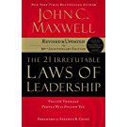

The 21 Irrefutable Laws of Leadership: Follow Them and People Will Follow You (10th Anniversary Edition)
by John C. Maxwell, Steven R. Covey (Hardcover)

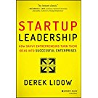

Startup Leadership: How Savvy Entrepreneurs Turn Their Ideas Into Successful Enterprises
by Derek Lidow (Hardcover)

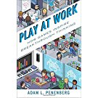

Play at Work: How Games Inspire Breakthrough Thinking
by Adam L. Penenberg (Hardcover)

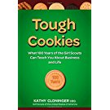

Tough Cookies: Leadership Lessons from 100 Years of the Girl Scouts
by Kathy Cloninger (Hardcover)

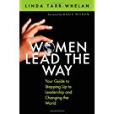

Women Lead the Way: Your Guide to Stepping Up to Leadership and Changing the World
by Linda Tarr-Whelan (Hardcover)

And here is the link for the Skyline library catalog to see what else we have available. And don’t forget the King County Library... anything they have electronically you can access with your ASB#. See Pg 2 here for reminders.

